Activity 1.1.5 Student Resource Sheet Serial Dilutions
In the lab, scientists often need to make dilutions of the same solution. Producing samples with different concentrations in a series is more time efficient than trying to prepare each sample one by one. A serial dilution is a stepwise dilution of a substance in solution. Calculating serial dilutions involves expressing the amount of sample in each tube as a fraction (1/X). The value of that fraction is the amount of sample (numerator) over the total volume (sample + diluent) in the tube (denominator). The diluent is the liquid that is doing the diluting. See the example below:

1 ml sample
+19 ml diluent
20 ml total volume
The dilution in Tube 1 = 1/20. Reduce the fraction if necessary.
Each tube dilution needs to be calculated and expressed as a fraction in the same way. Then, to determine the final sample dilution, multiply the fractions from each tube. In the example, the final dilution in Tube 2 is the dilution in Tube 1 (1/20) times the dilution in Tube 2 (1/20).
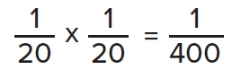

The final dilution in Tube 4 is the dilution in Tube 1 (1/20) times the dilution in Tube 2 (1/20) times the dilution in Tube 3 (1/20) times the dilution in Tube 4 (1/20).
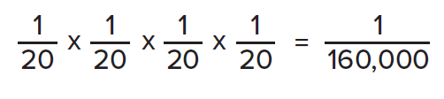

If the concentration of the first tube is known, the concentration of each subsequent tube can be calculated. For example, let us say that Tube 1, the first tube with a 1/20 dilution, has a concentration of 50 ng/ml. Therefore, the second tube has a concentration of:
50 ng ml x 1/20 = 2.5 ng/ml
The third tube has a concentration of:
2.5 ng/ml x 1/20 = 0.125 ng/ml
The final tube has a concentration of:
0.125 ng/ml 1/20 = 0.00625 ng/ml
If the ELISA test can still detect disease antigen or antibody at a dilution of 1/160,000 and a final concentration of 0.00625 ng/ml, the patient must have a very strong infection.
NOTE: If the amount of sample is not 1, set up a ratio and cross multiply to make the amount of sample = 1. See example below:
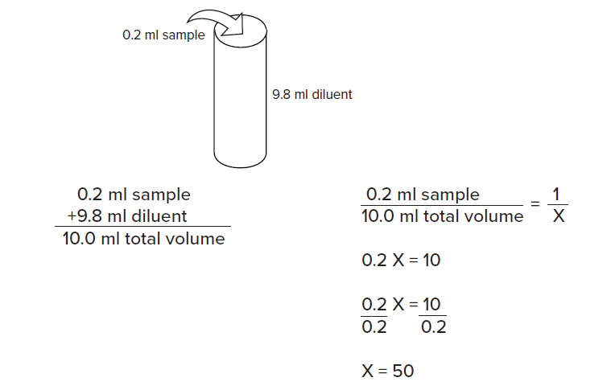

The dilution in the tube = 1/50.

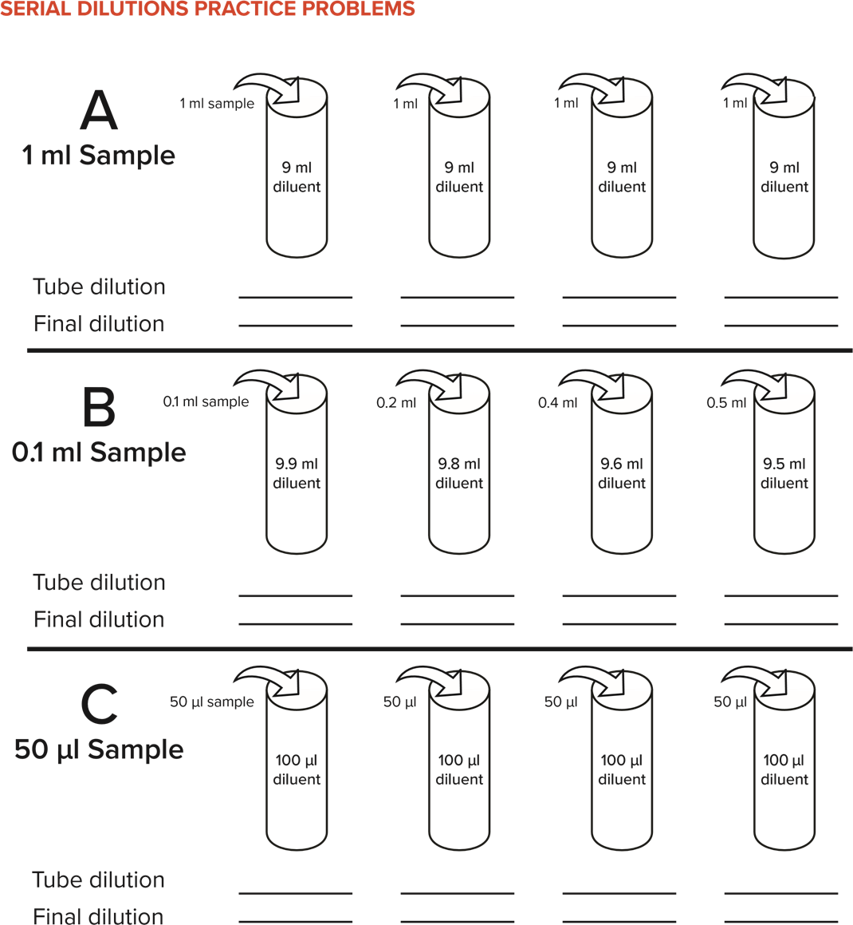

If the final concentration in the first tube in Problem C is 200 ng sample/ml, what is the concentration in the other three tubes? Show your work below.

